“Heaven's Light is Our Guide”

Rajshahi University of Engineering & Technology
Department of Electrical and Computer Engineering
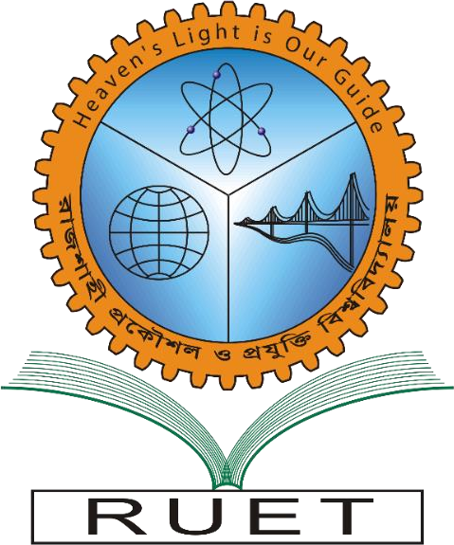

Course code: ECE-3108
Course title: Electrical Machine-II Sessional
Report number: 01
Date of submission: 11 January 2026

By:
Md. Shadid Hasan Niloy Akanda
Roll:2210024
Registration No. 1078/ 2022-2023
Department of ECE, RUET

Submitted To:
Moloy Kumar Ghosh
Assistant Professor
Department of ECE, RUET

